**Introduction to DBMS**

**DBMS –**

* Collection of inter-related data(Database)
* Set of software tools/programs which Access & Process the data.

This is also known as Query & Update.

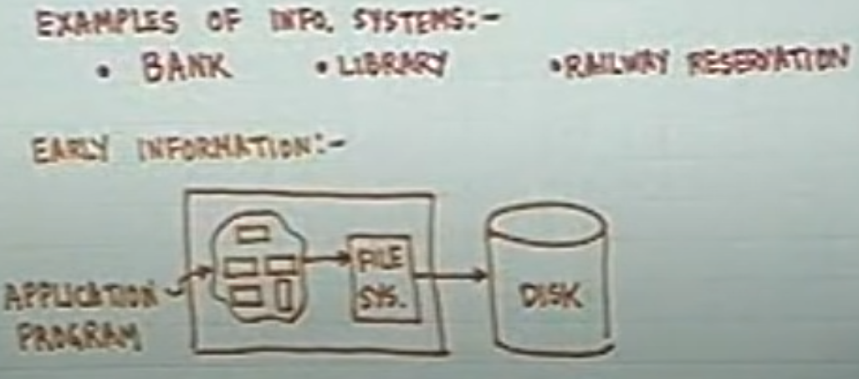

**Problem with Early information systems –**

1. **Disorganized Development**

- Data Redundancy

- Data Isolation

1. **Redundancy & Inconsistency**

Suppose that your data is stored in 5 places(Redundancy), now you update it in one place out of the 5. This makes the data inconsistent, there can other applications or users that are accessing data that is present in the 2nd place, but you updated data only at one point and due to this the user would not get the updated data!

1. **Concurrency**

5-6 people are updating the same data at the same point in time, this will give rise to the problem in the Updation of Shared Data.

Occurs due to accessing the Shared Data, example explains two persons, p1 & p2, are trying to book the same seat.

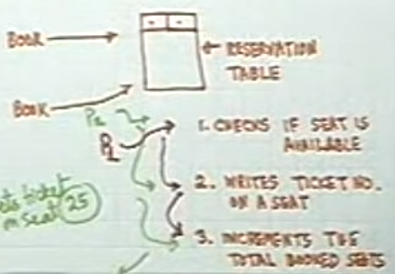

1. **Security**

**-----------------------------------------------------------------------------------------------------------------------------------------**

**Role of DBMS**

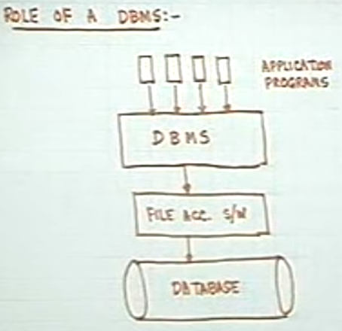

**Overall Organization – Data abstraction**

* **Physical Level:** This is generated or it is the end result of all the levels mentioned below.
* **Conceptual Level:** Database Admin

Here, Admin can write applications, programs, define the schema, in simple terms have access to all the data.(Record and Fields)

* **View Level:** Database Application users.

**Example:** Bank – Bank manager can access some View(Records and fields) and the clerks will have access to some other View(mostly less than what is given to the Bank manager)

**Note:** These DBA users can also update the data in a View.

We can see here the level of Abstraction, how it’s implemented using Views

* **User Level:** These are Naïve users, who just have viewing rights or access. Menu Driven.

Cannot update the data!

***Schema Definition – which will define the structure of your database***

***Instance – Variables or fields defined inside a Schema***

**Components of Database:-**

* **Data Definition Language (DDL)**

This is how you define the database, what are the data types, how are they related, and everything else. i.e. DATA DEFINITION

* **Data Manipulation Language (DML)**

Here we will write the program(query) to access the data, update the data **i.e. CRUD operations**.

1. Procedural
2. Non-procedural
3. Mixed(both procedural and non-procedural)

**Query Language –** A subset or sub-portion of DML.

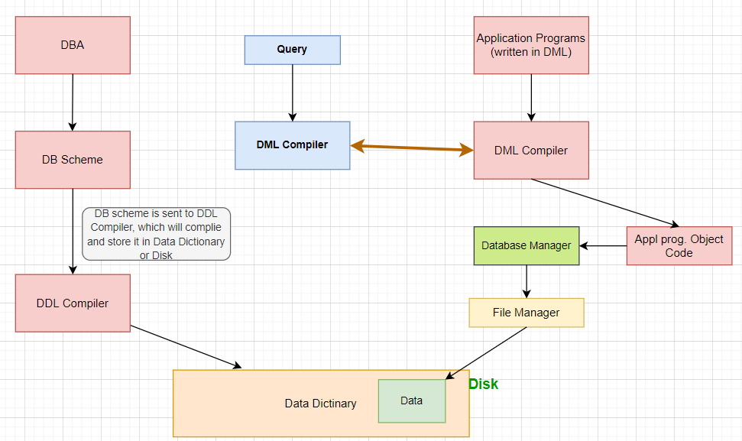

**Overview of DBMS-**

